Assignment
- Explain the difference between frontend, backend, and full-stack development with suitable real-world examples.
Ans- Key Differences
- Frontend Development
  - Works on the client side.
  - Deals with the visual appearance and user experience.
  - Ensures the website is responsive and interactive.
- Backend Development
  - Works on the server side.
  - Handles business logic, authentication, databases, and APIs.
  - Ensures data is stored securely and processed correctly.
- Full-Stack Development
  - Works on both client and server sides.
  - Can develop complete web applications independently.
  - Requires knowledge of both frontend and backend technologies.
Real-World Analogy
Think of a restaurant:
- Frontend = The dining area, menu, and waiter that customers interact with.
- Backend = The kitchen where chefs prepare food and manage orders.
- Full-Stack = A person who can both serve customers and cook the food, handling the entire restaurant process.

2. Create a simple diagram showing how the client-server model works in web architecture.
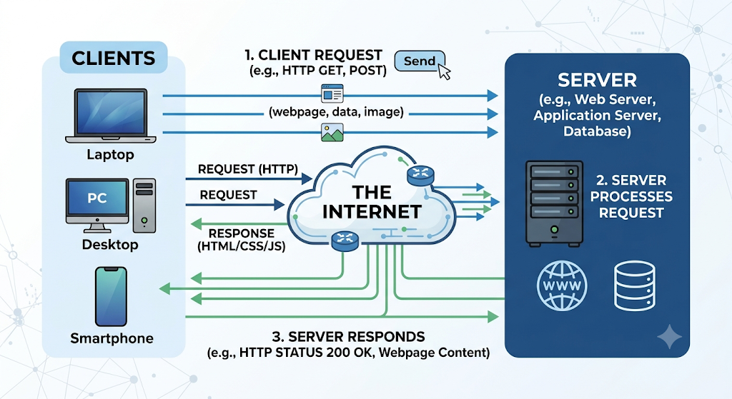
- Describe how a browser requests and displays a web page from a web server.
Ans-
- User enters a URL in the browser (e.g., www.example.com).
- Browser sends an HTTP request to the web server.
- Web server processes the request and retrieves the required web page or data.
- Server sends an HTTP response containing HTML, CSS, JavaScript, and other files.
- Browser downloads and renders these files.
- Web page is displayed on the user's screen.
- Identify and list the tools required to set up a web development environment. Explain the purpose of each.
Ans-
Tool | Purpose
Code Editor (VS Code) | Used to write and edit HTML, CSS, and JavaScript code.
Web Browser (Chrome, Edge, Firefox) | Runs and tests web pages.
Browser Developer Tools | Helps inspect, debug, and test web pages.
Git | Tracks code changes and manages versions.
GitHub | Stores and shares code online.
Node.js | Runs JavaScript outside the browser and installs packages.
npm (Node Package Manager) | Installs and manages project libraries and dependencies.
Local Server (Live Server/XAMPP) | Runs the website locally for testing and development.
- Explain what a web server is and give examples of commonly used servers.
Ans- A web server is software (or a computer) that stores website files and delivers them to users' web browsers when they request a web page using HTTP or HTTPS.
Examples of Web Servers
- Apache – Open-source web server for hosting websites.
- Nginx – Fast web server used for high-traffic websites.
- Microsoft IIS – Web server for Windows applications.
- LiteSpeed – High-speed server commonly used for WordPress sites.

- Define the roles of a frontend developer, backend developer, and database administrator in a project.
Ans-
Role | Responsibility
Frontend Developer | Designs and develops the user interface (UI) that users see and interact with using HTML, CSS, and JavaScript.
Backend Developer | Builds the server-side logic, APIs, and handles data processing and user requests.
Database Administrator (DBA) | Manages, secures, and maintains the database to store and retrieve data efficiently.
- Install VS Code and configure it for HTML, CSS, and JavaScript development. Take a screenshot of the setup.
Ans-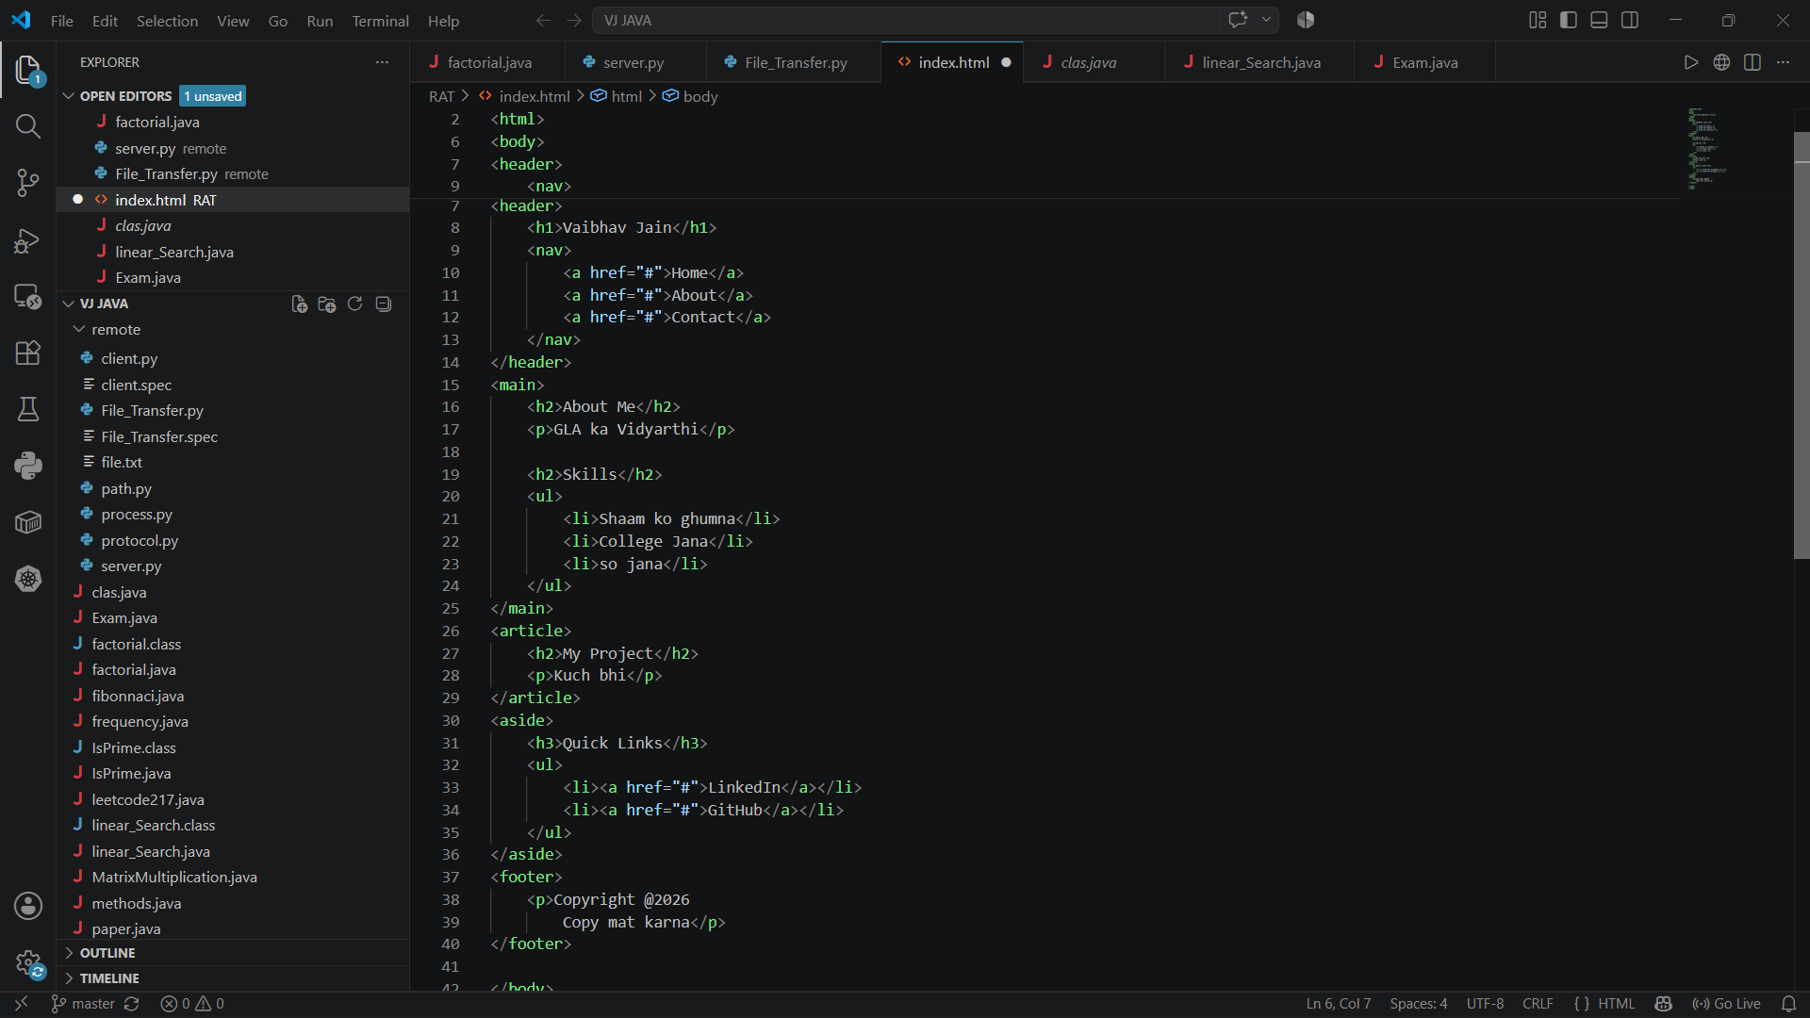
- Explain the difference between static and dynamic websites. Provide an example of each.
Ans-
Static Website | Dynamic Website
Shows the same content to every user. | Content changes based on the user or data.
Built using HTML and CSS. | Uses HTML, CSS, JavaScript, and backend languages (PHP, Python, Node.js, etc.).
Easy and fast to load. | More interactive and database-driven.
Examples
- Static Website: Personal portfolio or company information website.
- Dynamic Website: Amazon, Facebook, or Instagram.
- Research and list five web browsers. Explain how rendering engines differ between them.
Ans-
Web Browser | Rendering Engine
Google Chrome | Blink
Mozilla Firefox | Gecko
Microsoft Edge | Blink
Apple Safari | WebKit
Opera | Blink
- Blink – Fast and widely used; powers Chrome, Edge, and Opera.
- Gecko – Developed by Mozilla; used only in Firefox.
- WebKit – Developed by Apple; optimized for Safari and Apple devices.

- Draw a labeled diagram showing the basic web architecture flow — client, server, database, and APIs.
Ans-